**Name: Himanshu Yadav, Maan Pratap Singh , M Suman Kumar**

**Reg No:- 11807655 , 11807726 ,11807731**

**Roll No :- 05 , 06 ,22**

**Sec :- K18JE**

**Abstract:**

Chess which do play between two players on a board is intellectual and mental game. It has its own rules of play which help to enhance and improve the mental and intellectual activities of the player, and this game has a huge amount of players around the all world they have strongly interested to have play it. This document deals with the fully computerized Chess Game, the game computerizes for two players to do play chess according all the valid rules of the chess on computer. Secondly for making the game more interesting that will make users to direct do play against computer, computer intellectual force is added.

**Introduction:**

Chess is a game for two players, dubbed White and Black. The goal is to capture your opponent's king. In the game, this is known as a checkmate. Chess is played on a board with 64 squares. Each player begins with 16 pieces, lined up in two rows. The 1st row is occupied by pieces called pawns. The next row contains: a king, a queen, two rooks, two bishops and two knights. Chess is a game of perfect information", because both players are aware of the entire state of the game world at all times. Just by looking at the board, you can see which pieces are alive and where they are located. Checkers, Gomoku, Backgammon are other members of the category, but stud poker is not. (you do not know what cards your opponent is holding in his hands)

Here that able to change chess game from physical form to fully realistic, several things are needed to make chess game computerized and intelligent.

**Literature review:**

For making computerized chess game, which will let two players to play chess

game in computer realistic. We need two things which we must introduce to

computer.

* Some way to represent a chess board in memory, so that it knows what the state of the game is.
* Rules to determine how to generate legal moves, so that it can play without cheating (and verify that its human opponent is not trying to pull a fast one on it).
* 1st we should introduce chess board and its elements to computer, next we need to produce movement for chess pieces according to rule if chess game.

**Proposed methodology:**

* This code is in python where we have implemented the method of A* method and also method named as heuristic which returns the Manhattan distance that is the difference of a grid from present location to its desired location in goal state and a method named as moves which returns the set of all possible moves in a scenario To a computer, it is far from obvious which of many legal moves are "good" and which are "bad".
* The best way to discriminate between the two is to look at their consequences (i.e., search series of moves, say 4 for each side and look at the results.) And to make sure that we make as few mistakes as possible, we will assume that the opponent is just as good as we are. This is the basic principle underlying the minimax search algorithm, which is at the root of all chess programs.
* Unfortunately, minimax' complexity is O(bn), where b ("branching factor") is the number of legal moves available on average at any given time and n (the depth) is the number of "plies" you look ahead, where one ply is one move by one side. This number grows impossibly fast, so a considerable amount of work has been done to develop algorithms that minimize the effort expended on search for a given depth. Iterative-deepening Alpha-beta, Nega-Scout and MTD(f) are among the most successful of these algorithms, we will discuss with more detail later in this document.
* Another major source of headaches for chess programmers is the "horizon effect", 1st described by Hans Berliner. Suppose that your program searches to a depth of 8-ply, and that it discovers to its horror that the opponent will capture its queen at ply 6. Left to its own devices, the program will then proceed to throw its bishops to the wolves so that it will delay the queen capture to ply 10, which it cannot see because its search ends at ply 8. From the program's point of view, the queen is "saved", because the capture is no longer visible... But it has lost a bishop, and the queen capture reappears during the next move's search. It turns out that pending a position where a program can reason correctly about the relative strength of the forces in presence is not a trivial task at all, and that searching every line of play to the same depth is tantamount to suicide. Numerous techniques have been developed to defeat the horizon effect.

**Result and discussion:**

This is interface of the program output:

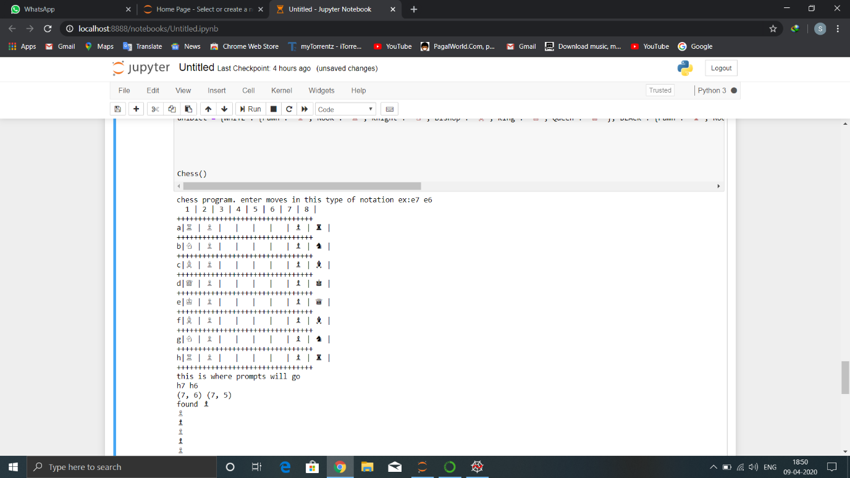

Here we make a move in algebraic notation like h7 h6 i.e.(h7 place piece will go to h6)

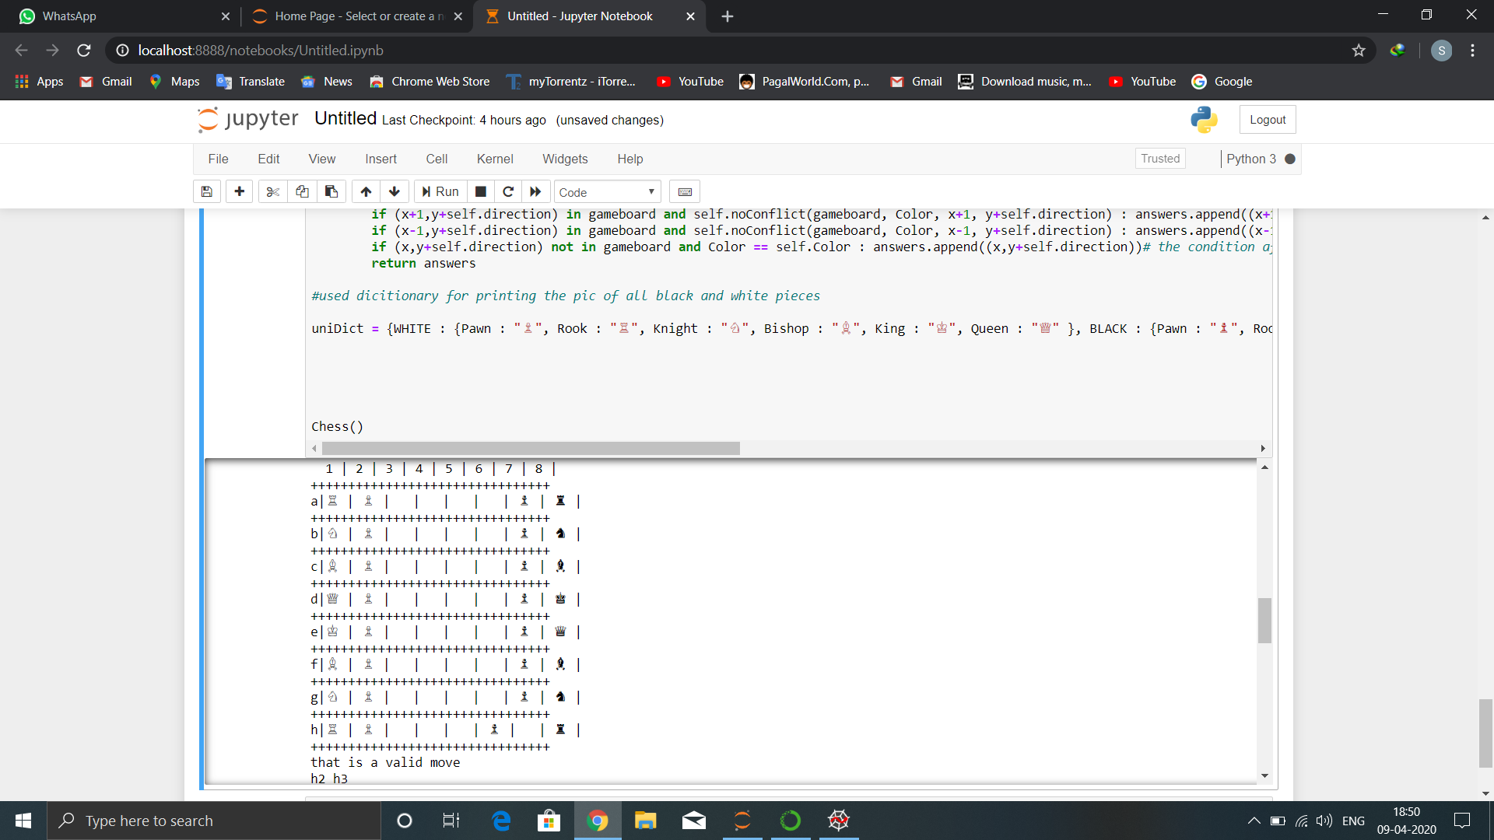

Here we made the opponent move i.e.h2 h3

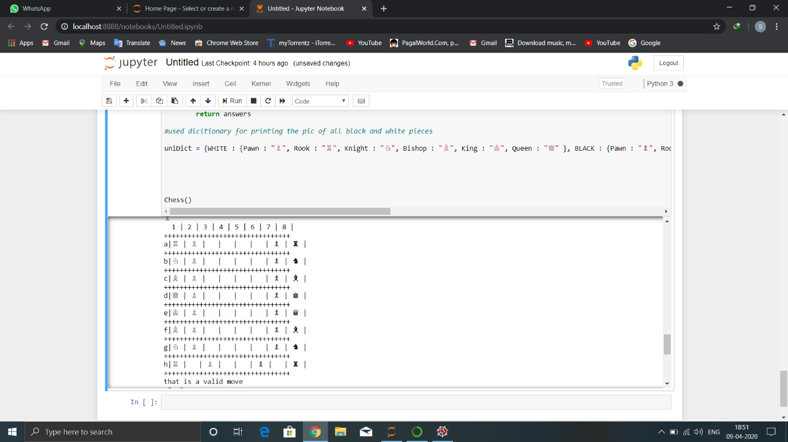

Here we call a wrong move so it shows invalid move.

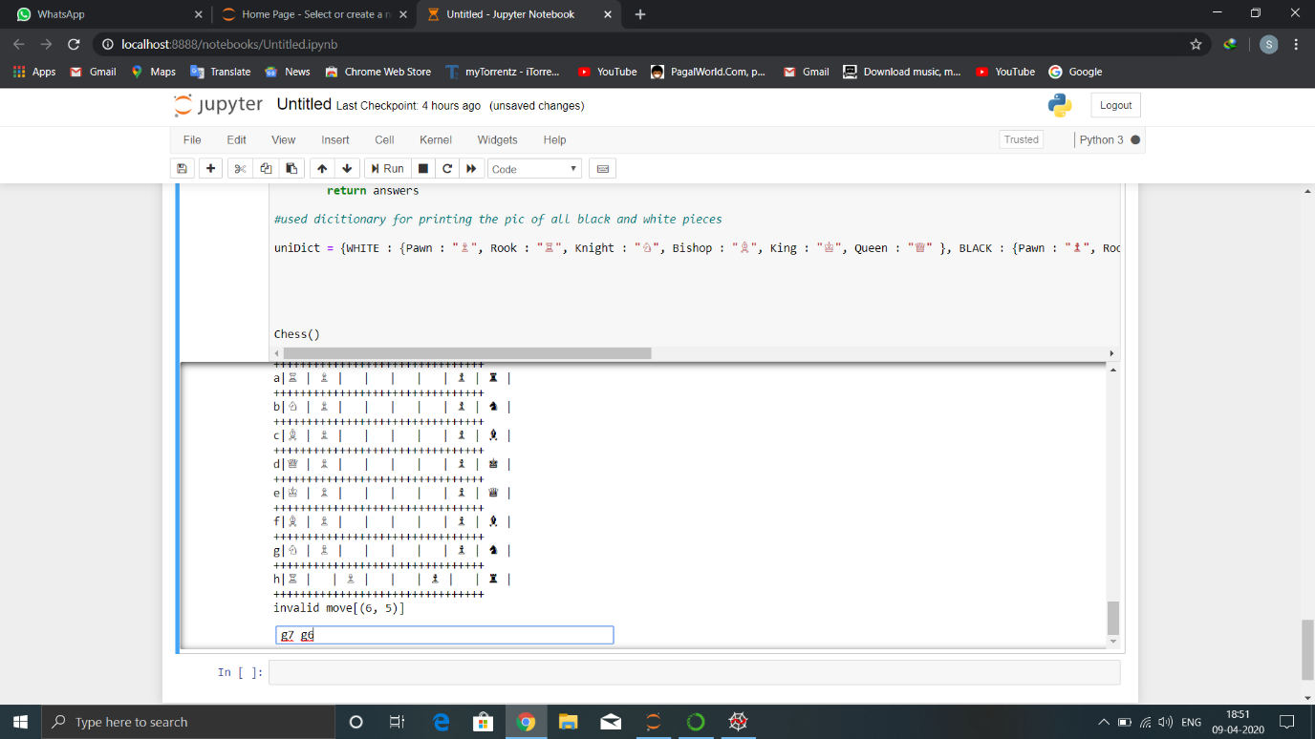

Here we move g7 g6:

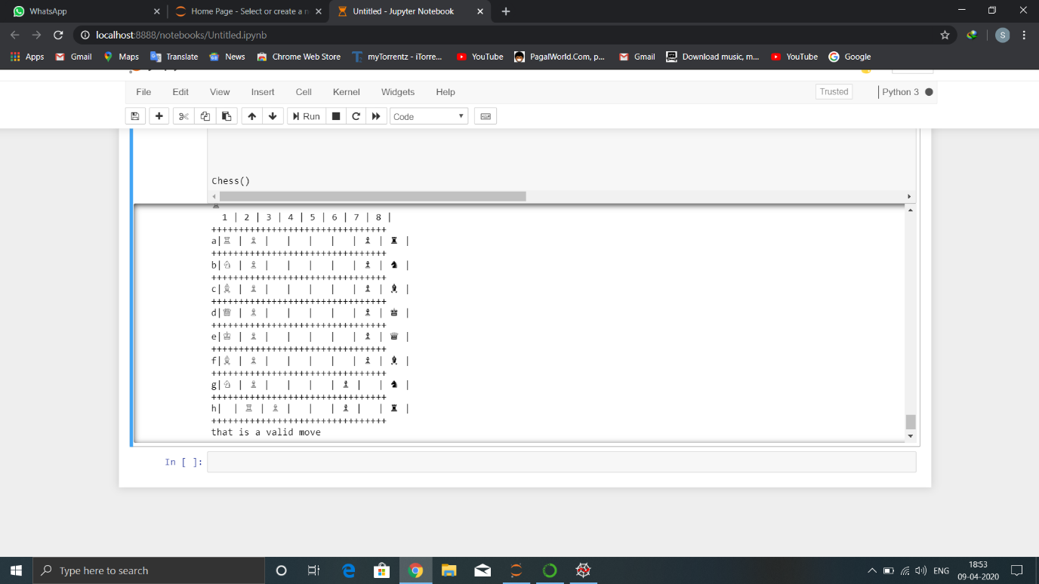

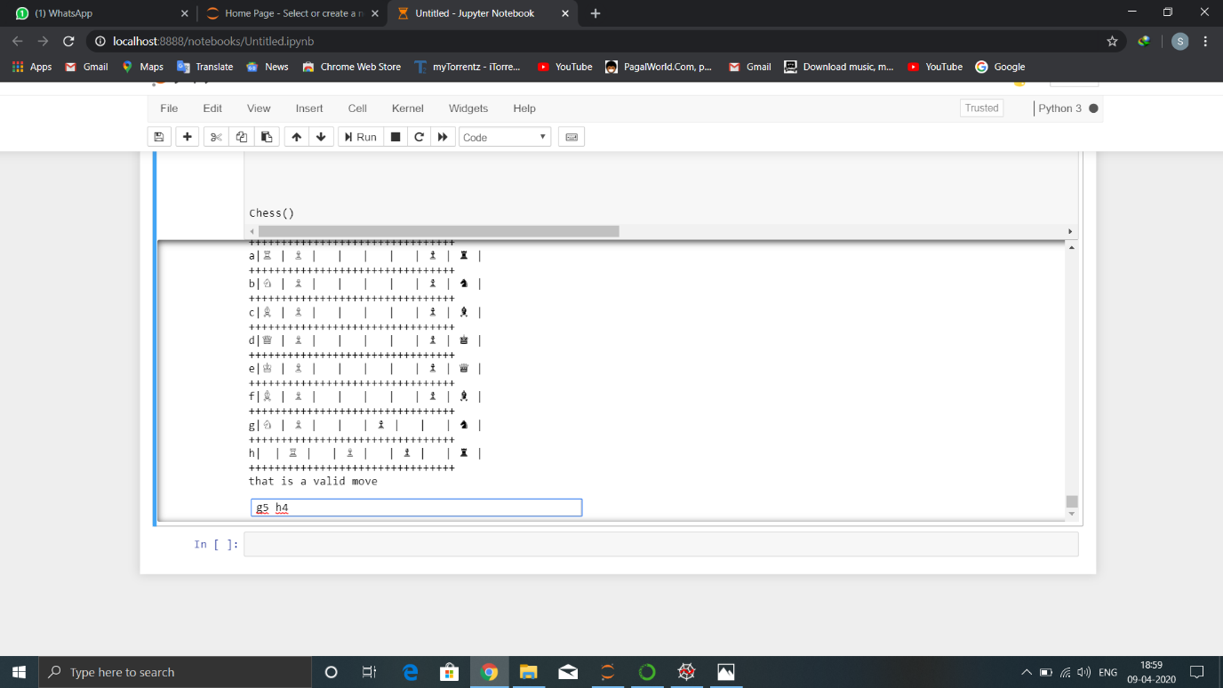

In this we make a move to eliminate one of white piece:

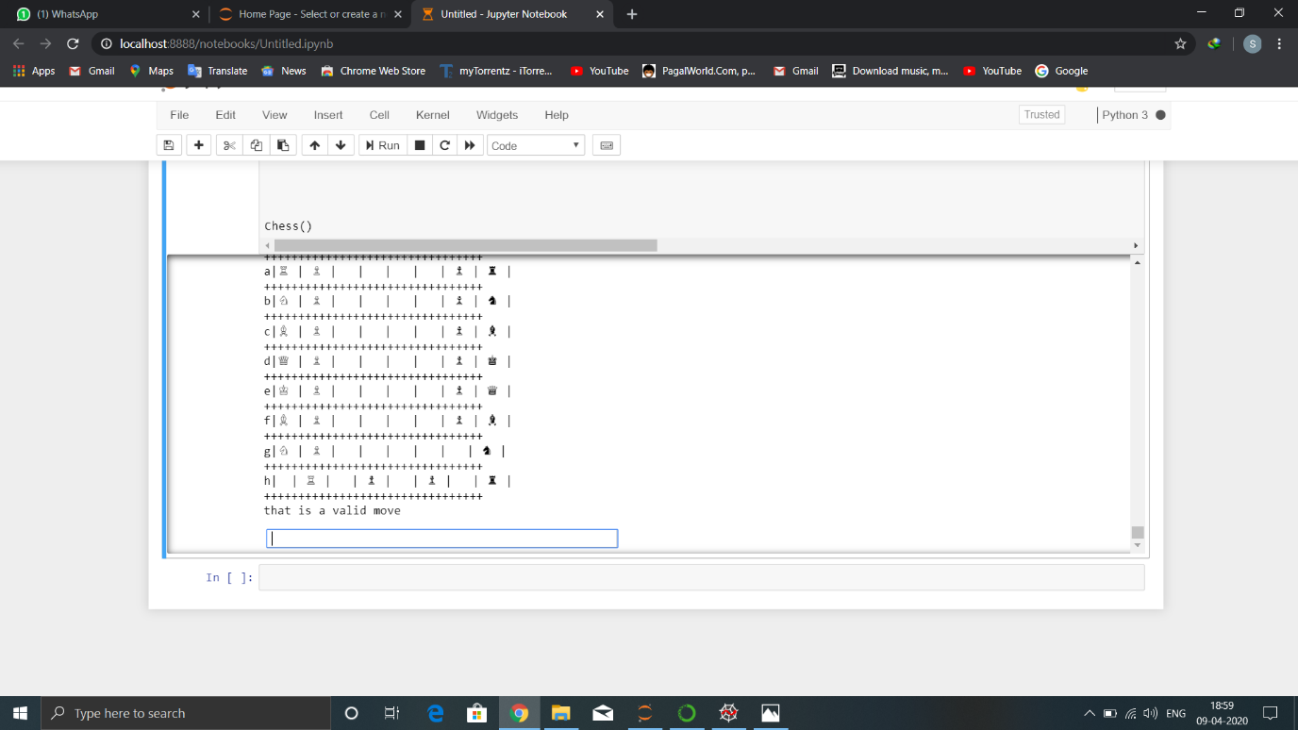

**Conclusion:**

This project was really helpful in building up the ability to think critically about the algorithm which we used in the project and also that time can be saved by implementing algorithms for solving problems rather than solving it manually, however building this code required certain perquisites like possible moves in the given scenario, rules for solving the Chess etc. The scope of artificial intelligence is very large in today’s era where machines are taking over difficult jobs and thereby increasing the productivity.

**References:**

Python crash course book by Eric Matthes.

Python essential reference book by M.Beazley.